**Assignment no 2**

**Aim:** Create a database with appropriate constraints using DDL and modify it with the help of DML.

Creating a database and a table:

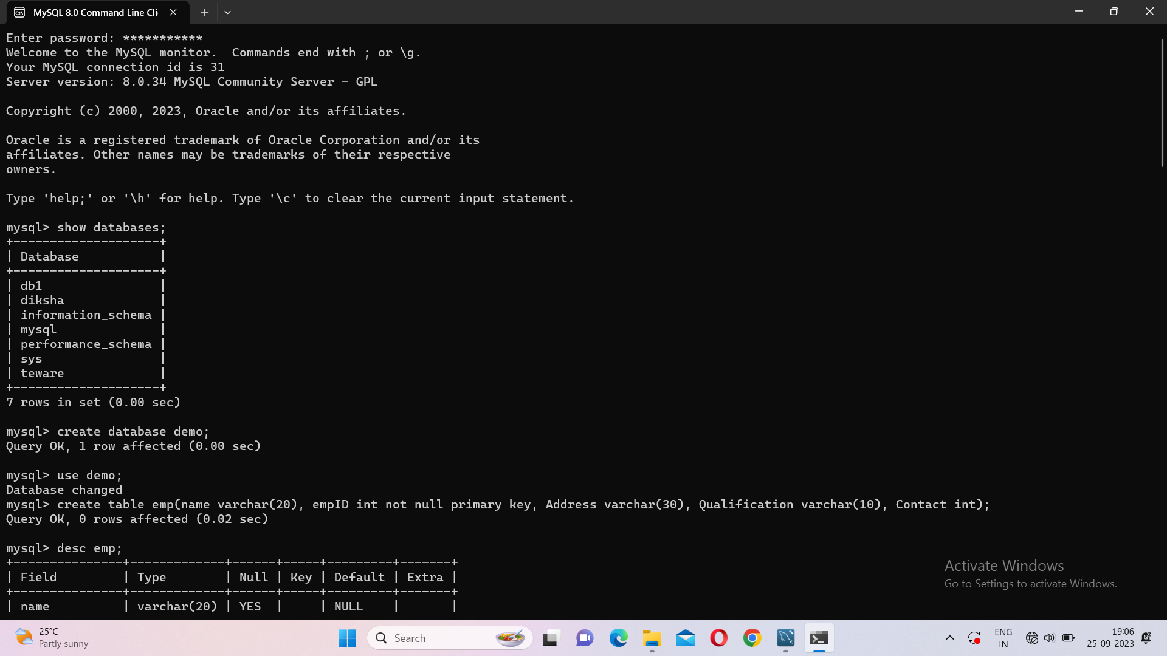

Inserting values in table:

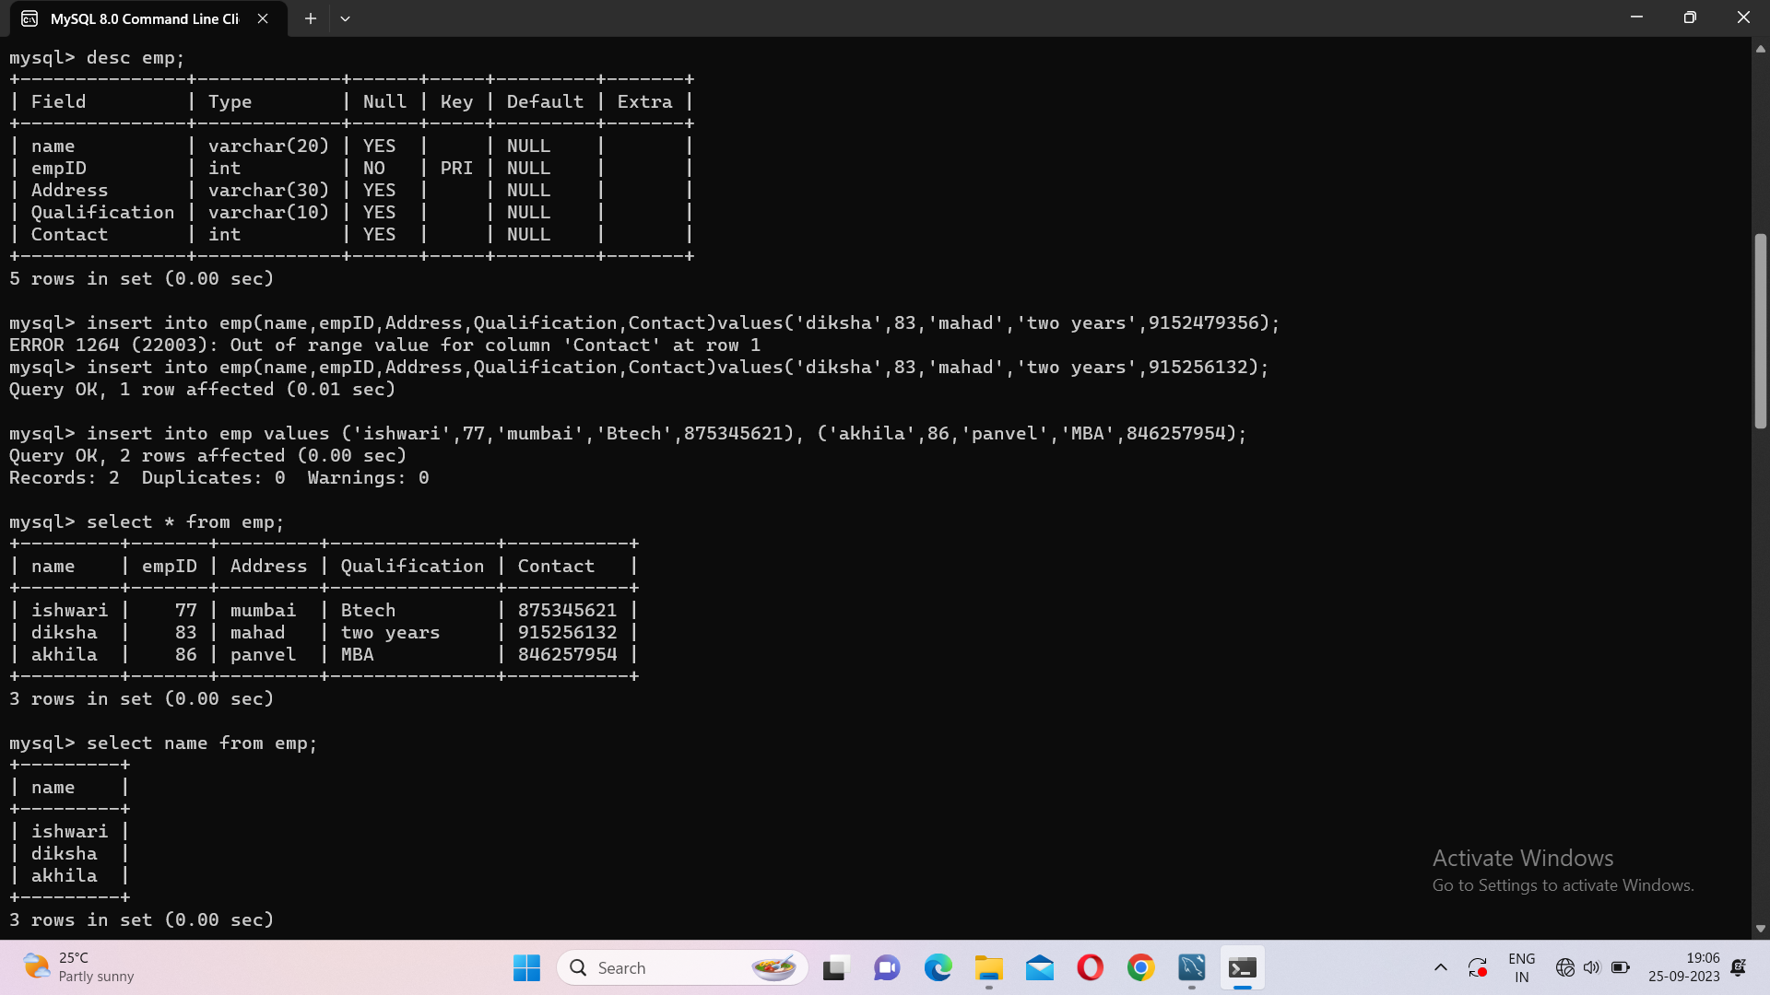

Update statement:

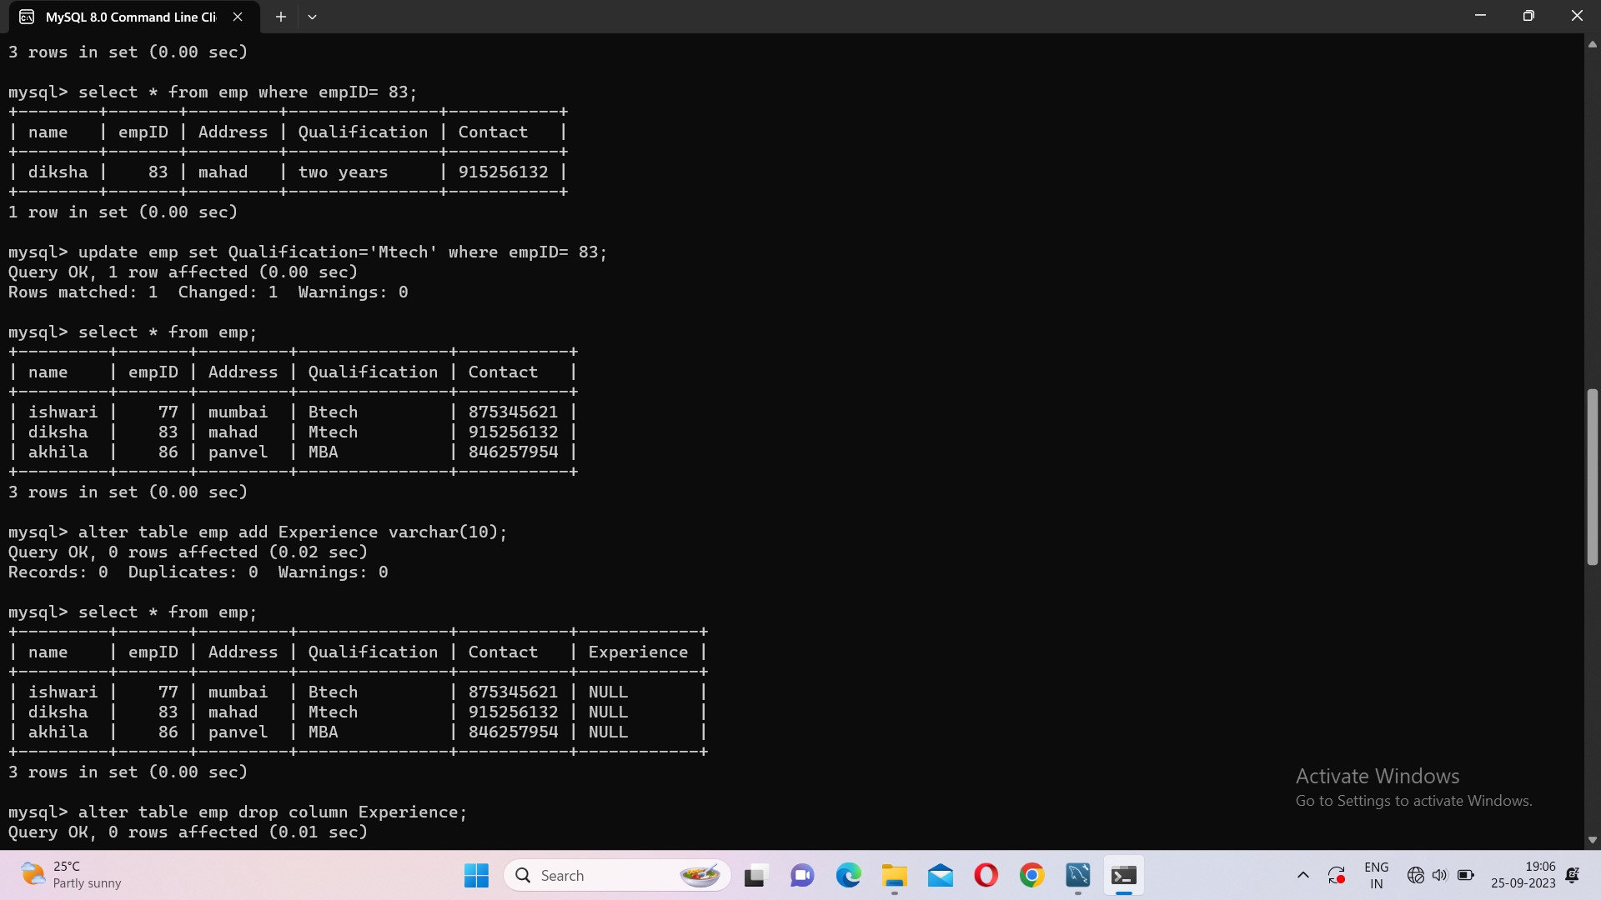

Alter with add:



Alter with drop:

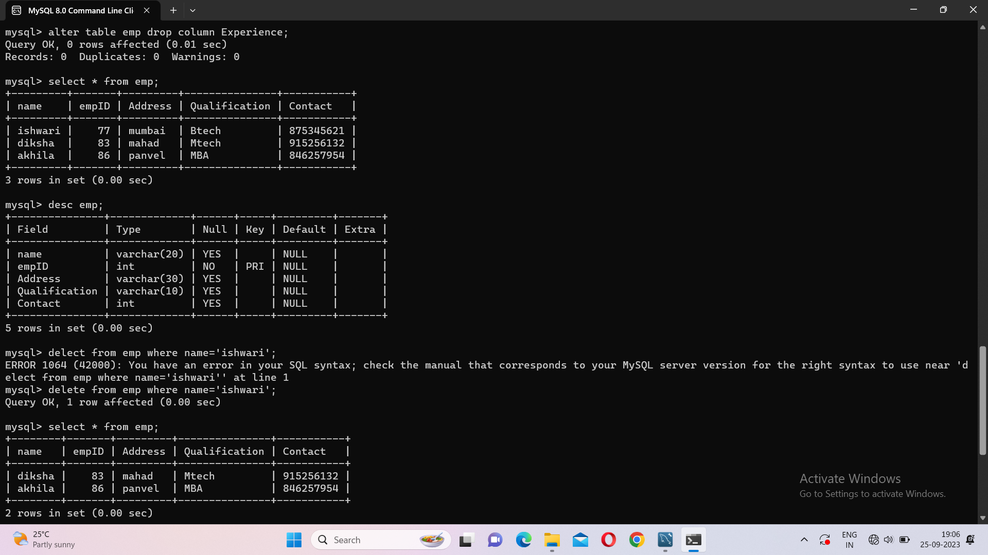

Delete statement:

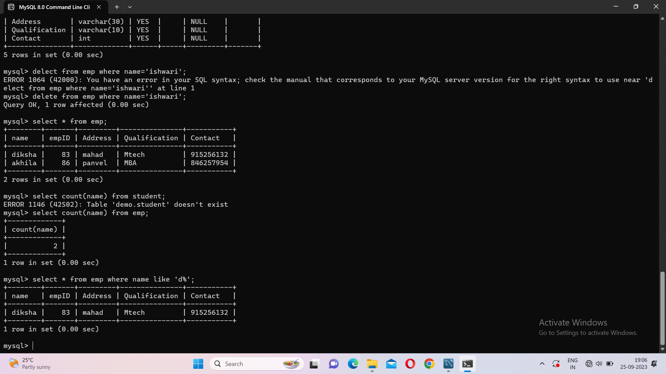

Select with count:



Select statement with where:

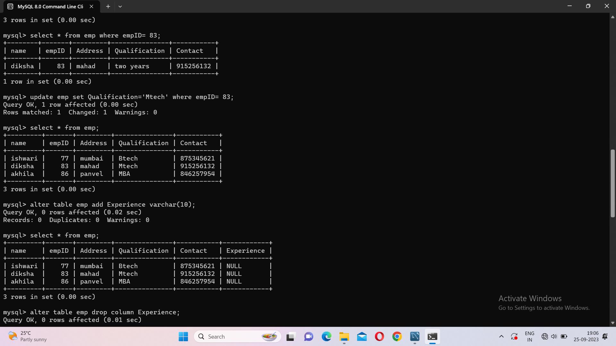

SQL primary key constraint:

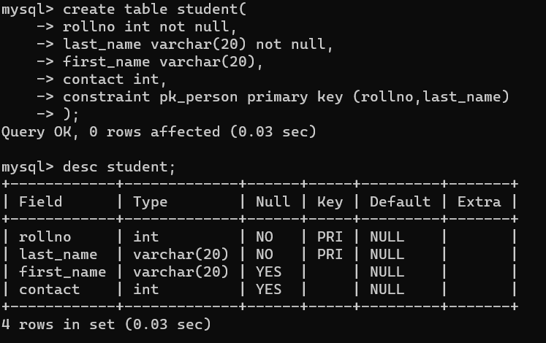

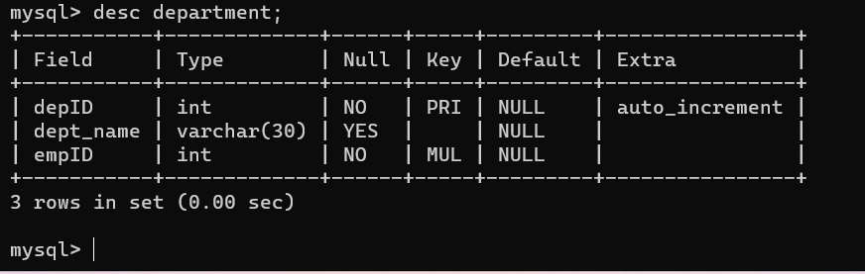

Drop a primary key constraint:

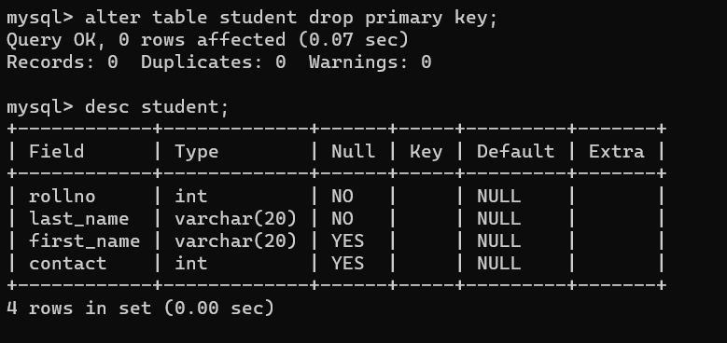

SQL Foreign key on create table:

